SVCR GOVERNMENT DEGREE COLLEGE, PALAMANER
Open Day Programme Report
The Open Day Programme at SVCR Government Degree College was organized with the objective of creating awareness among junior college students about higher education opportunities, campus facilities, academic environment, and career pathways available at the institution. The programme served as a bridge between junior college and degree education, helping students make informed decisions about their future studies. It was a well-planned and meaningful event that highlighted the college’s commitment to quality education and student development.
The programme was conducted on the college campus in a welcoming and academic atmosphere. Junior college students from nearby institutions attended the event along with their faculty members. Their presence added enthusiasm and importance to the programme, as it provided them with firsthand exposure to degree-level education. The visiting students were warmly received by the staff and student volunteers of SVCR Government Degree College.
The event began with a formal welcome session. The organizing committee ensured that the guests were comfortably seated and guided to the venue. The programme started with an introduction about the purpose of the Open Day and the importance of choosing the right course and institution for higher studies. The coordinators explained how such programmes help students understand real campus life beyond brochures and advertisements.
The Principal of the college, Dr. M. Venkatesulu, played a key role in the programme. He addressed the gathering and shared valuable insights about higher education, discipline, and career planning. He explained the vision and mission of SVCR Government Degree College and emphasized the institution’s dedication to academic excellence and holistic development. Using a panel board presentation, he clearly described the college facilities, courses offered, laboratories, library resources, digital learning support, and extracurricular opportunities. His explanation helped students gain a clear understanding of the infrastructure and academic strengths of the college.
The Vice Principal, Dr. K. Nandeeswaraiah, also spoke on the occasion. He highlighted the importance of skill development, value-based education, and consistent effort in achieving success. He encouraged students to make use of government educational institutions that provide quality education at an affordable cost. His speech motivated students to think seriously about their goals and the role of higher education in shaping their future.
The IQAC Coordinator, Dr. Shaik Benazeer, explained the quality initiatives undertaken by the college. The role of the Internal Quality Assurance Cell (IQAC) in maintaining academic standards, organizing seminars, workshops, and student support programmes was clearly described. Students were informed about mentoring systems, career guidance, and continuous improvement practices followed by the institution. This session helped students understand that the college focuses not only on teaching but also on overall quality enhancement.
All faculty members actively participated in the programme and delivered short speeches about their respective departments. They explained subject combinations, career opportunities after graduation, and the importance of choosing courses based on interest and ability. Faculty members also shared success stories of former students who progressed to good careers and higher studies. These real examples inspired the visiting students and built confidence in the institution.
One of the highlights of the programme was the interaction session. Junior college students were given the opportunity to ask questions regarding admissions, scholarships, facilities, and student life. The faculty members answered patiently and provided clear guidance. Students showed curiosity about laboratories, computer facilities, sports, and cultural activities. The responses helped remove doubts and provided clarity about campus life.
The visiting students were also taken on a brief campus tour. They visited classrooms, laboratories, the library, and other important facilities. The library attracted special attention due to its collection of books and study resources. The laboratories demonstrated the practical learning environment available for science students. This tour gave students a realistic view of the learning atmosphere at the college.
The programme also emphasized student support services such as counselling, scholarships, and co-curricular activities. The speakers informed students about government scholarships available for eligible candidates and encouraged them to continue their education without financial fear. Information about clubs, NSS, NCC, and cultural activities showed that the college promotes overall personality development.
The Open Day Programme created a positive impression among the visiting students and their faculty. Many students expressed that they gained useful information and felt more confident about joining degree courses. Faculty members from junior colleges appreciated the initiative and coordination. They felt such programmes are highly beneficial in guiding students toward higher education.
In conclusion, the Open Day Programme at SVCR Government Degree College was informative, inspiring, and well-organized. It successfully introduced junior college students to the opportunities and facilities available at the degree level. Such programmes play an important role in guiding students toward the right academic path and building confidence about higher education. The initiative reflects the college’s commitment to student outreach and educational development. Overall, the programme was a great success and left a lasting positive impact on all participants.
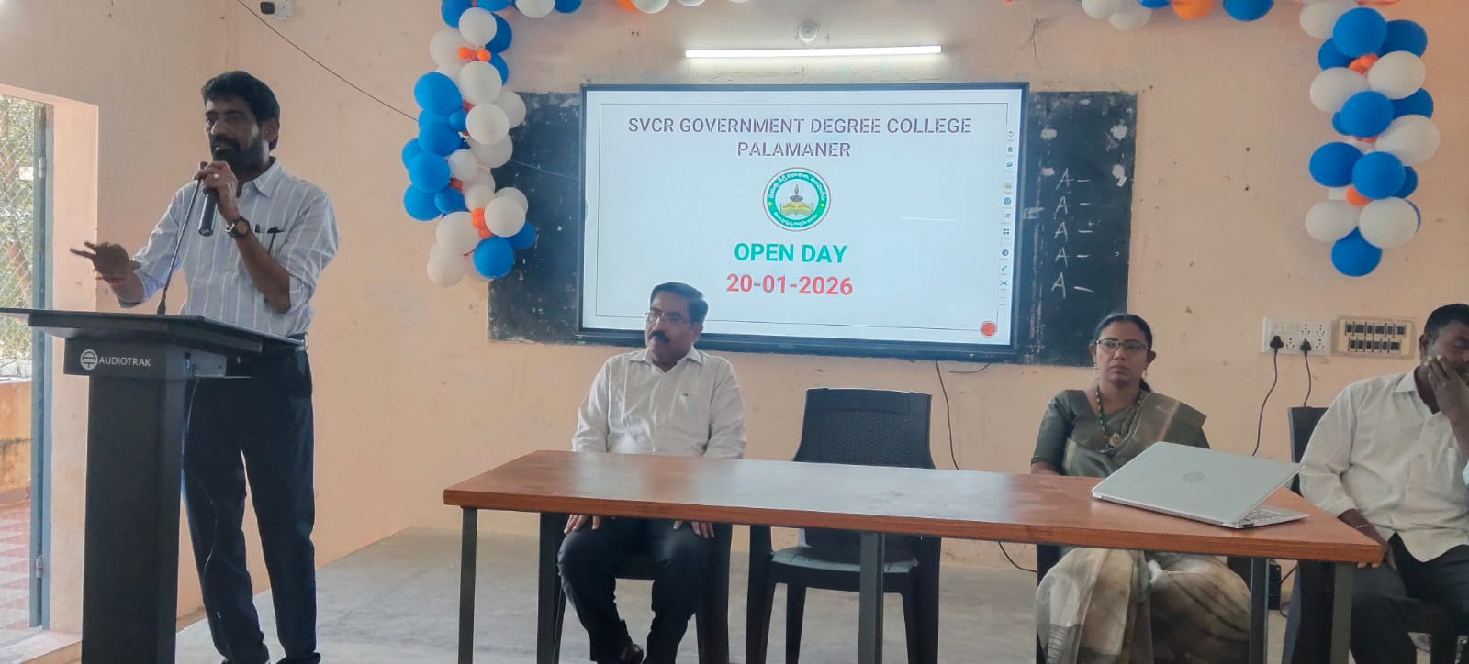
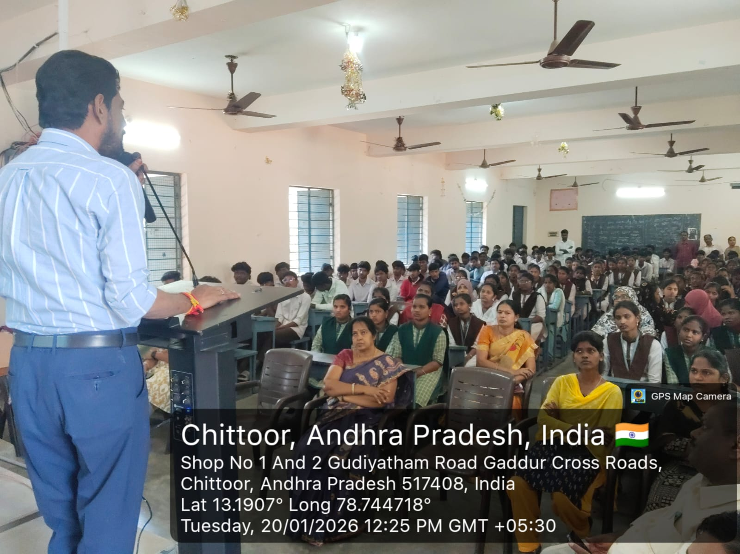
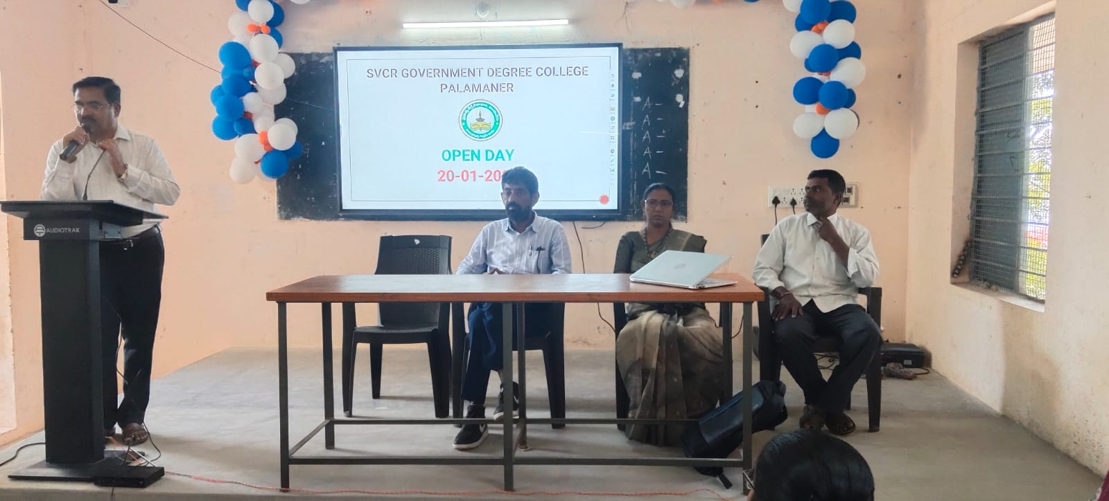
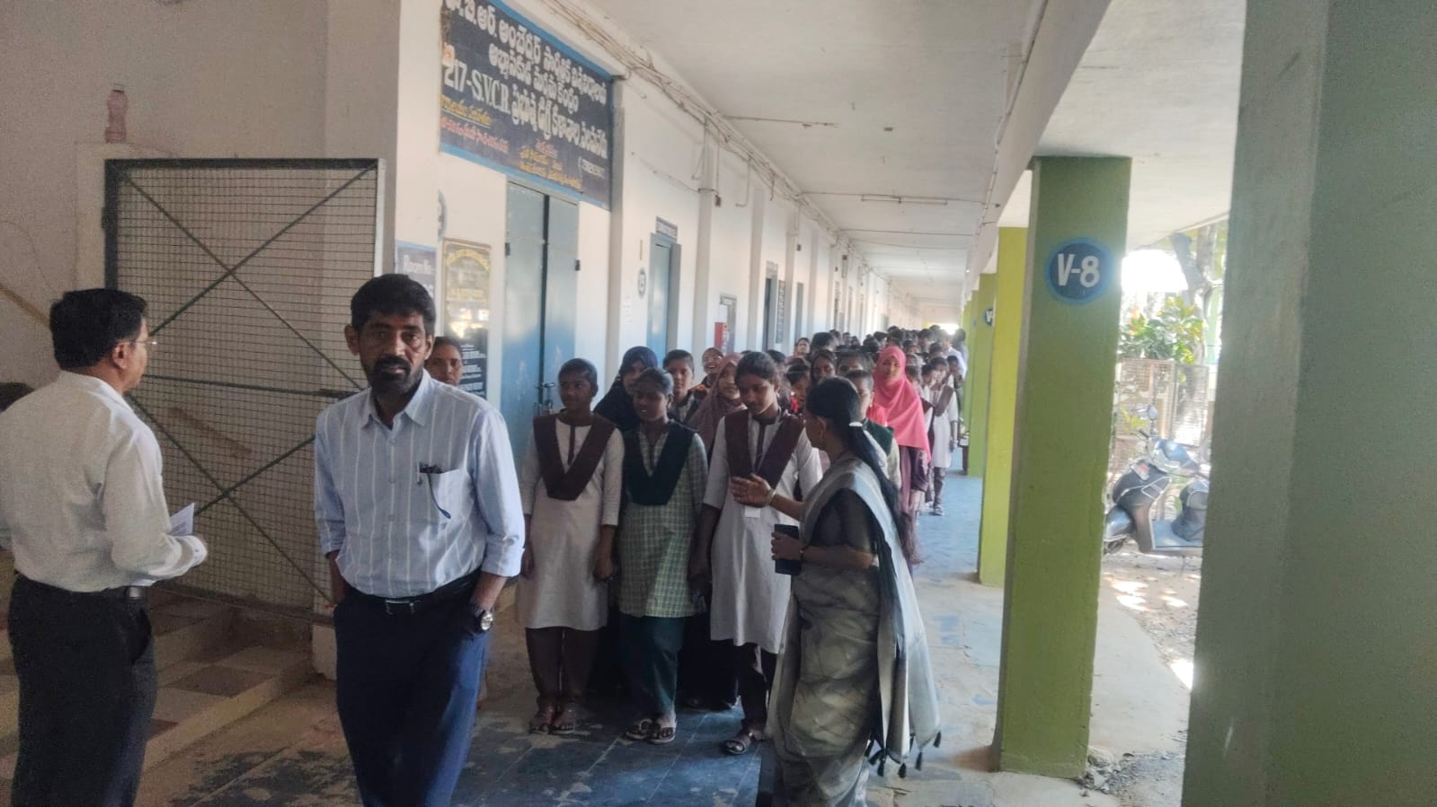
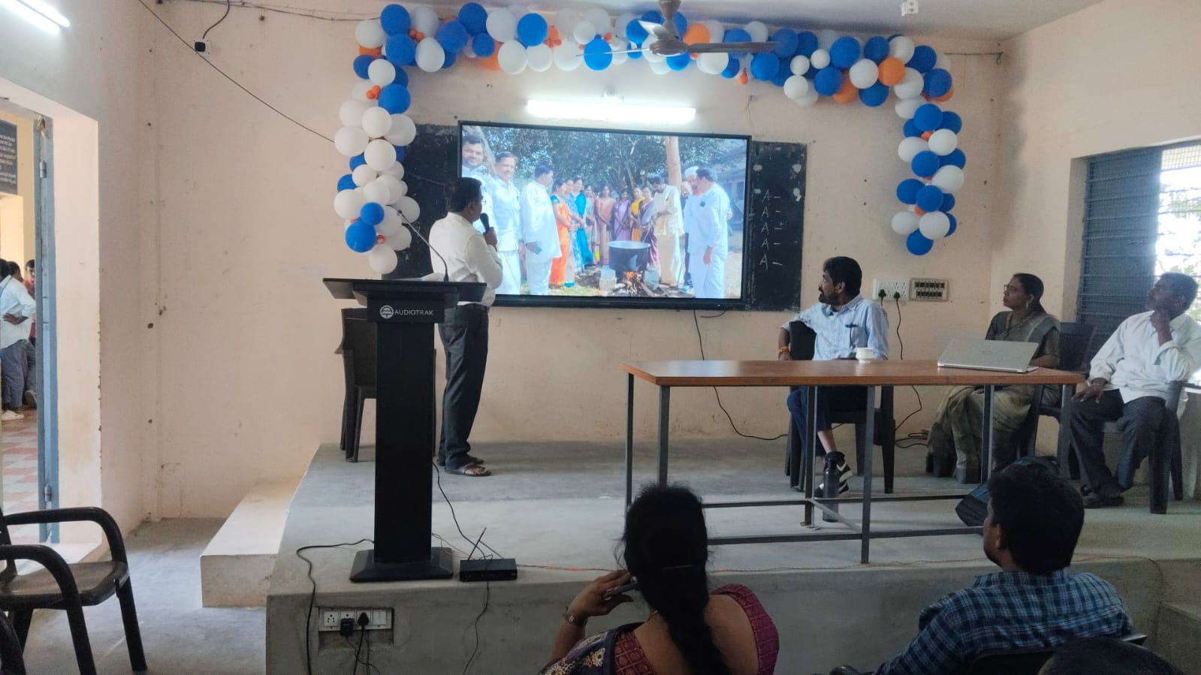
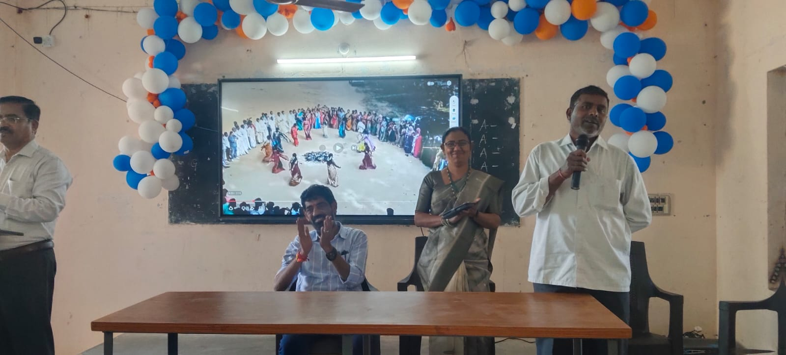
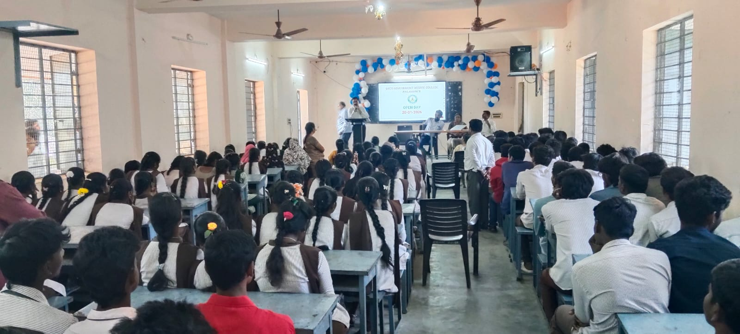
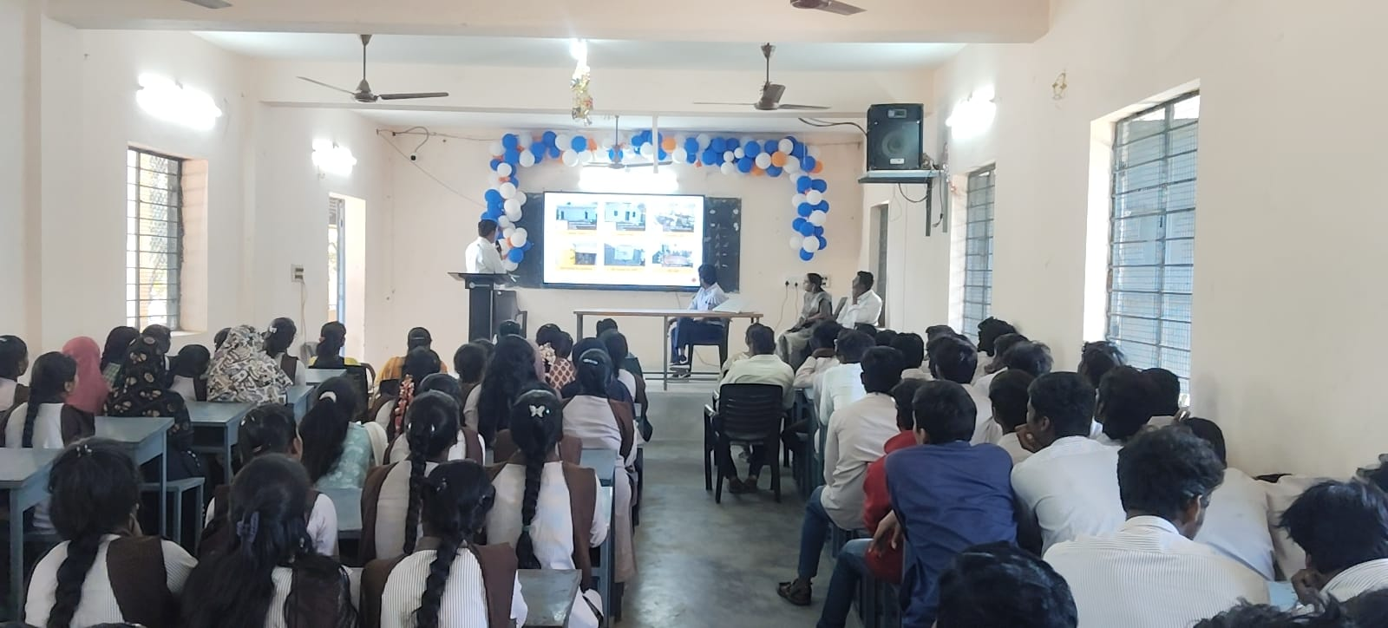
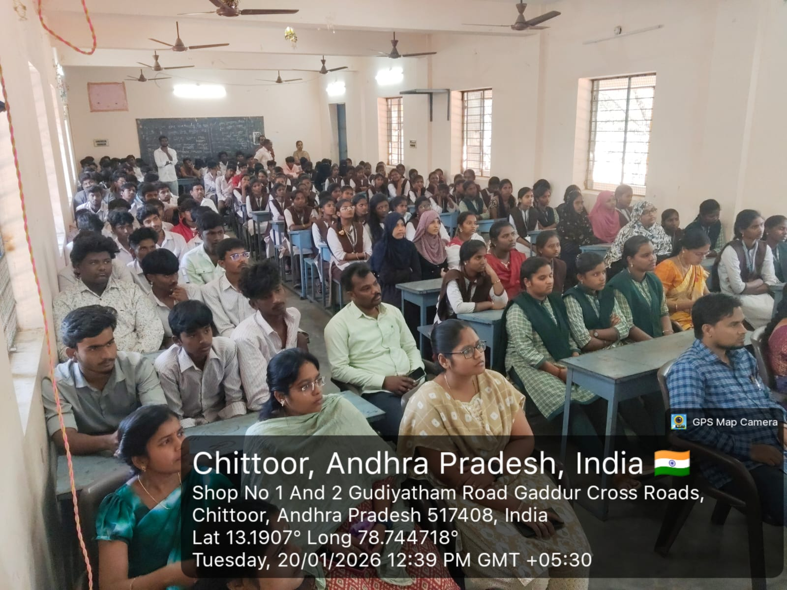
JKC VISIT
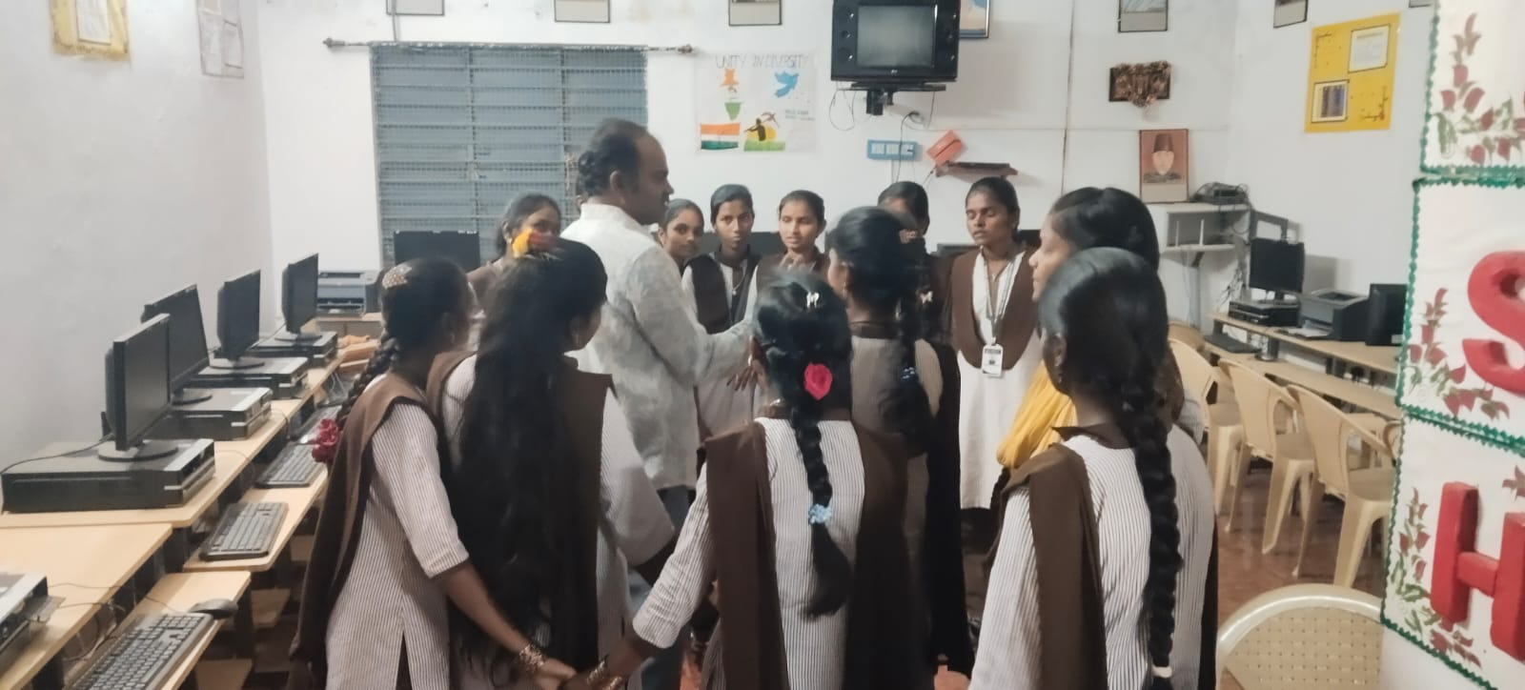
LIBRARY VISIT
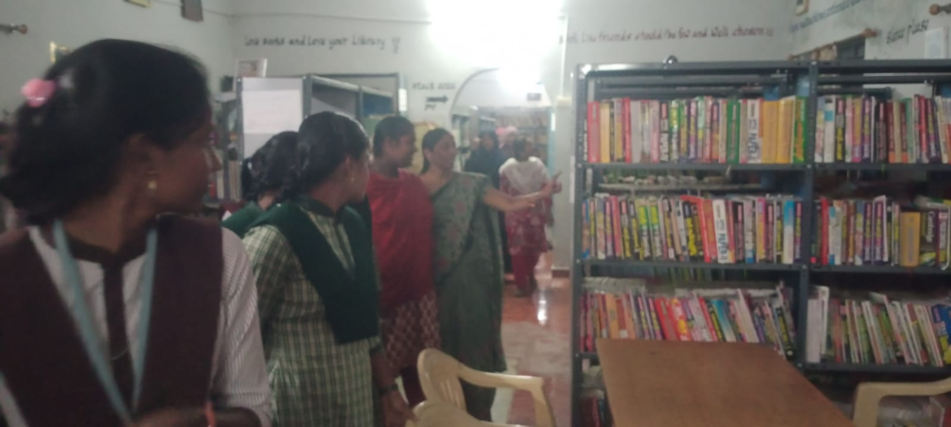

DEPT OF CHEMISTRY
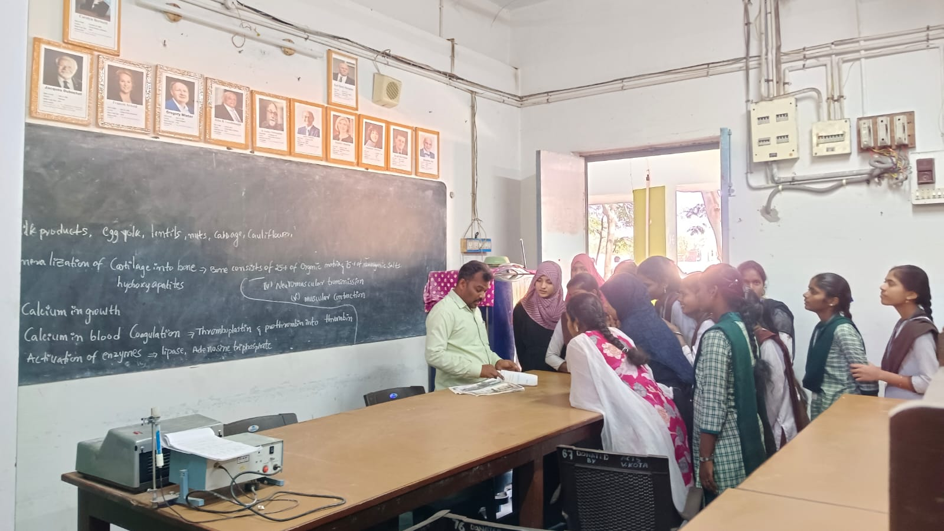
DEPT OF ZOOLOGY
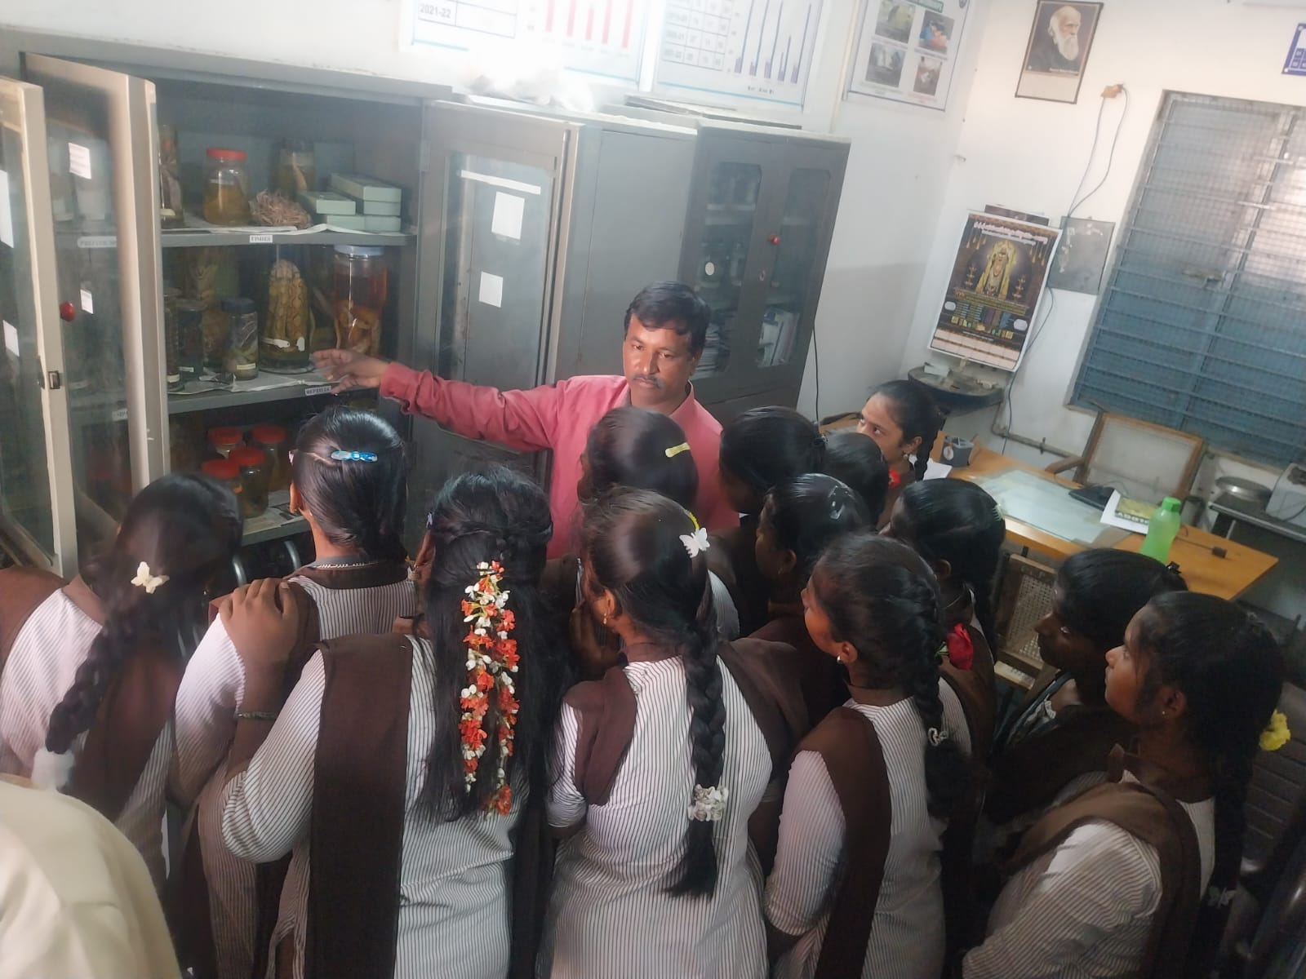
DEPT OF BOTANY
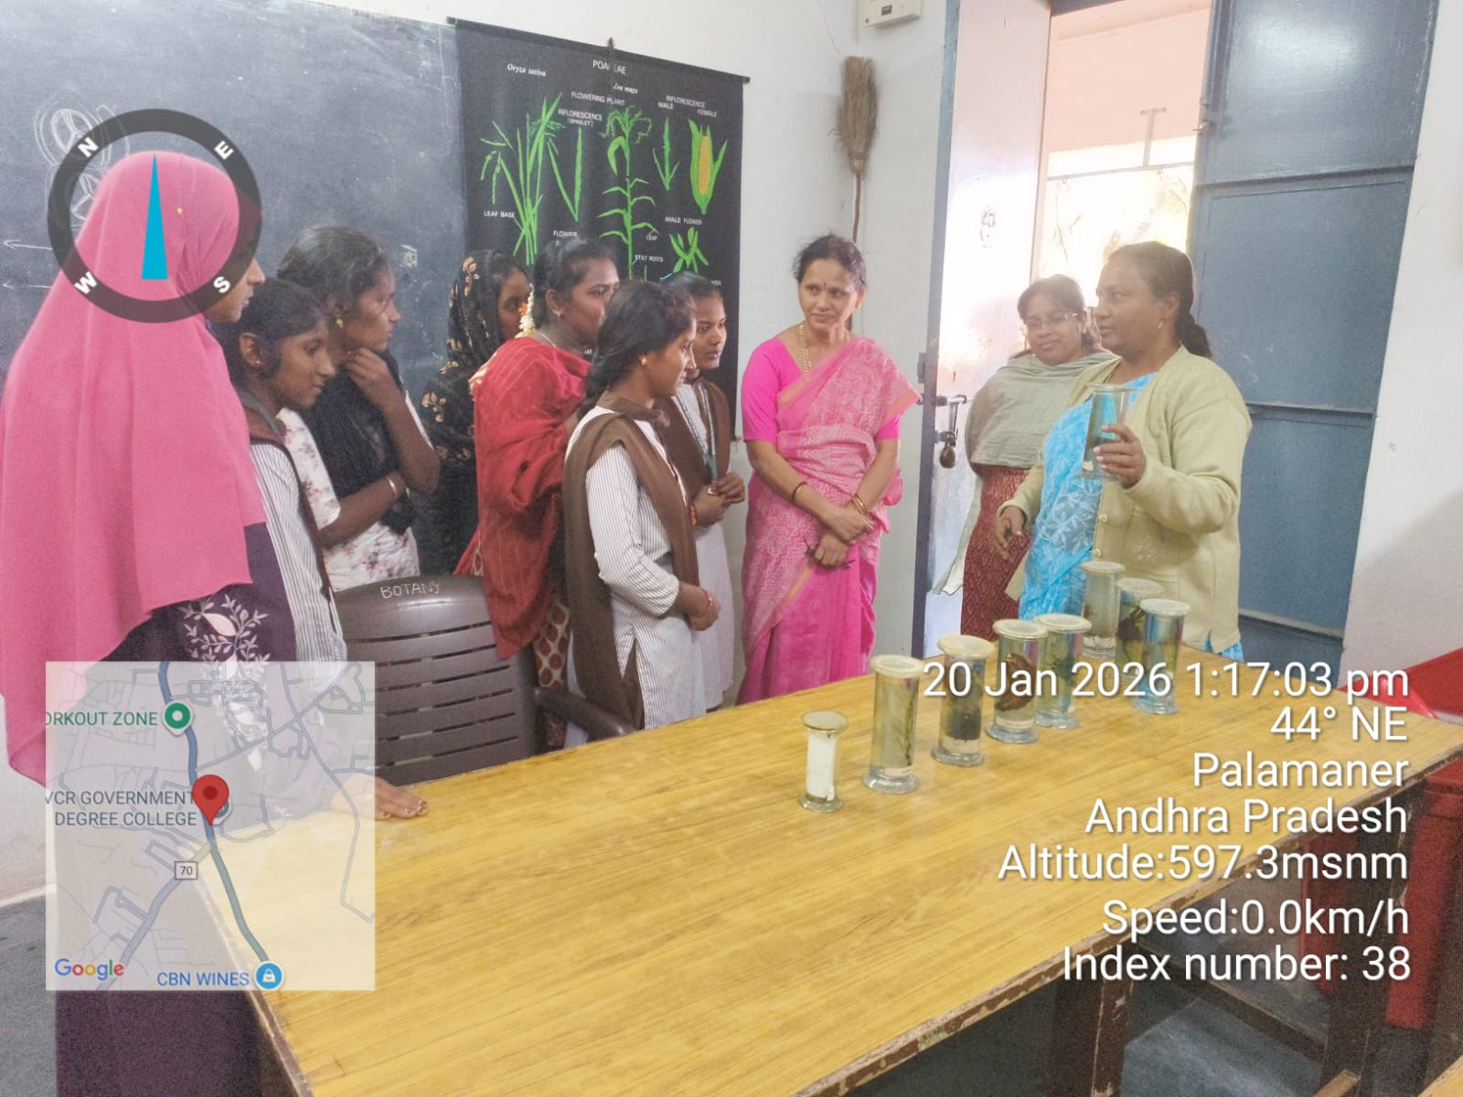
DEPT OF PHYSICS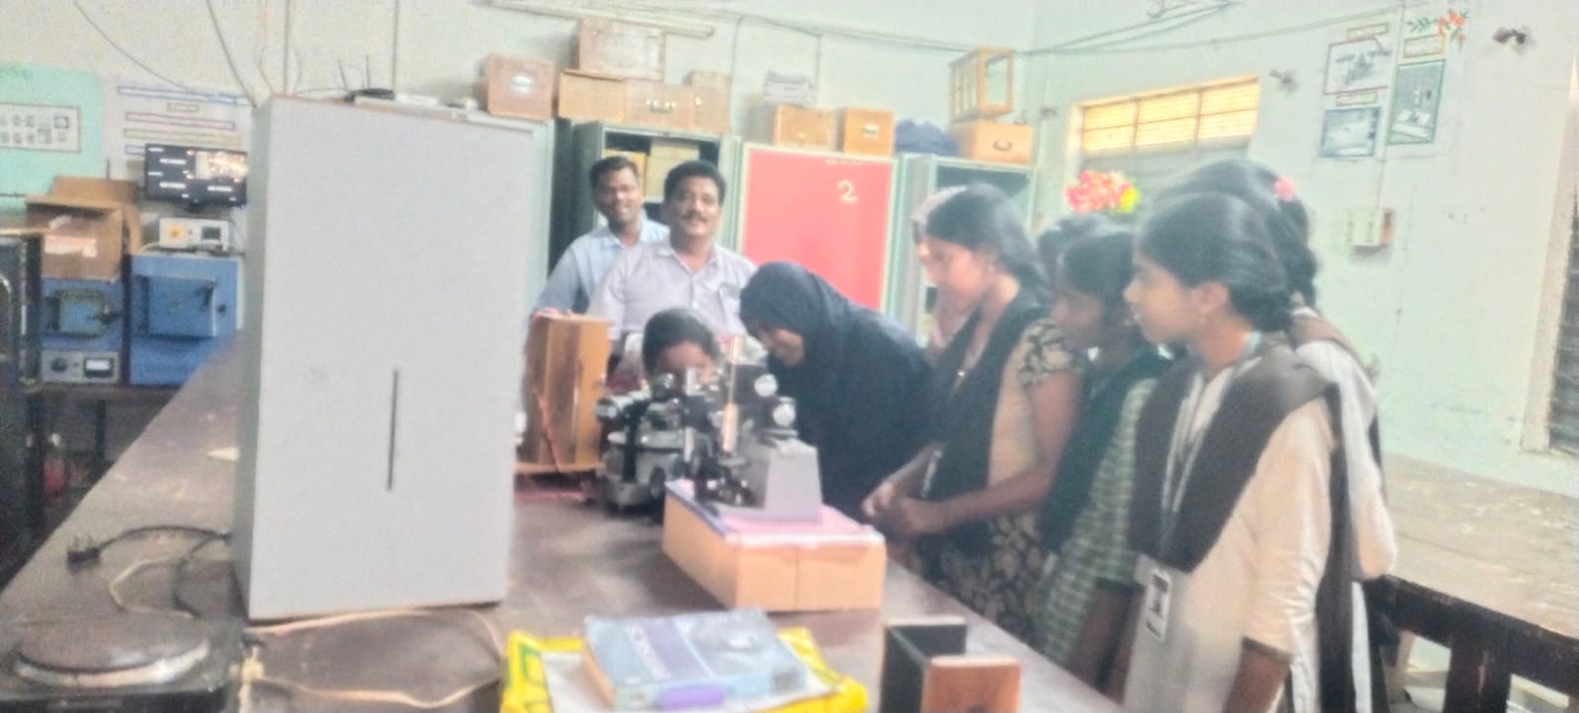
PAPER CLIPPINGS
